Orange County Sheriff’s Department

Background Unit
320 N. Flower St. (4th Floor)
Santa Ana, CA 92703

Phone: (714) 834-5311
Email: Backgrounds@ocsheriff.gov

Visit: ocsheriff.gov

INSTRUCTIONS, AUTHORIZATION, AND
PERSONAL HISTORY STATEMENT

The following instructions are provided as a guide and assist you. This form, which you are required to fill out, must be complete and detailed in all respects. It is the basis for your background investigation.

The Personal History Statement can be found on the Orange County Sheriff’s Department website at OCSHERIFF.GOV click to Join OCSD, then click on Personal History Statement for New Applicants. It is highly recommended that you save a copy. This form cannot be electronically transmitted. Personal History Statement must by typed on single sided paper.

It is to your advantage to respond openly. Any negative factor in your background will be evaluated in terms of the circumstances and facts surrounding its occurrence, and its degree of relevance to this position. For example, being fired from a job or having an arrest record may not in itself be grounds for disqualification. During the investigation, the investigator will inquire into the facts surrounding such an occurrence. An evaluation will then be made of the relevance of these facts to this position.

Do not attach documents such as resumes, credit reports, Department of Motor Vehicle printouts or driver’s licenses, etc. in lieu of the information requested in the Personal History Form.

All zip codes, addresses (including city names), telephone numbers, and other pertinent information must be included or the Personal History Form cannot be processed in a timely manner. All boxes must be filled in. If a question does not apply to you, enter “DNA” in the space provided.

Bring the completed form and your personal documents with you to the background interview. This interview will last approximately 2 hours. This is the process that starts your background investigation. The appointment will be at the Sheriff’s Department, 320 N. Flower St 4th floor, Santa Ana, 92703. Parking will be at your own expense, no validation.

Please bring the following original forms and 1 complete set of copies to the appointment. The information will be verified and noted. Your originals will be returned to you.

- Birth Certificate (Original or Certified Copy) / Naturalization Papers / Resident Card

California Driver’s License
- Social Security Card
- Proof of Current Automobile Liability Insurance (Listing you as an Insured Driver)
- Authorization to Release Information (We do not notarize)

If you do not understand any part of the form, ask for assistance; call the Background Unit at, (714) 834-5311.

Birth Certificate (Original)
Naturalization Certificate
Samples of what is and what is not accepted:
ACCEPTED
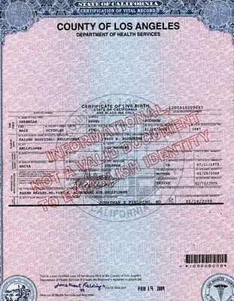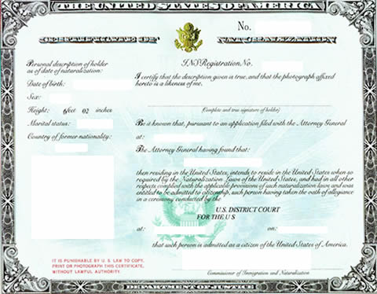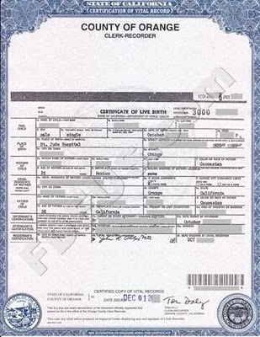

NOT ACCEPTED
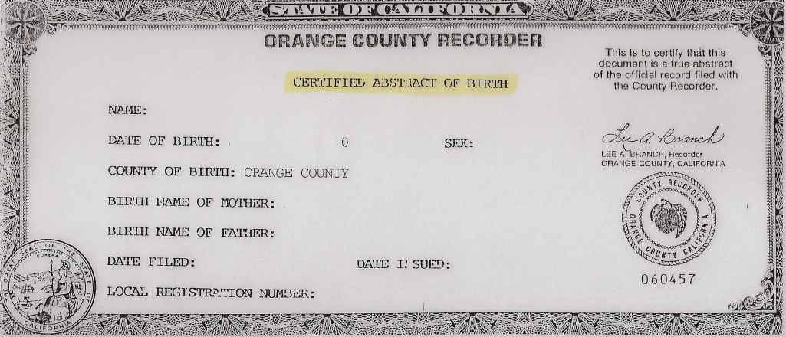

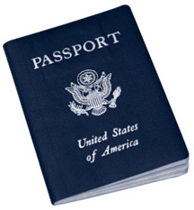
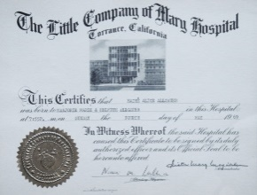
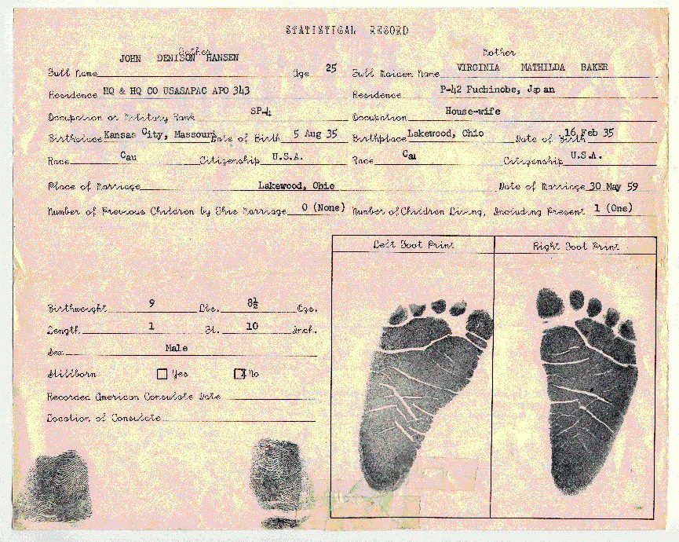

PROVIDE (2) COPIES OF THIS PAGE

Home address on driver’s license needs to be current.
(We do accept PO BOX address)
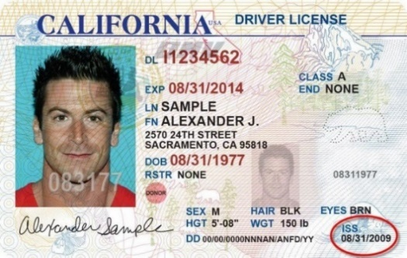
Please make sure, it is signed
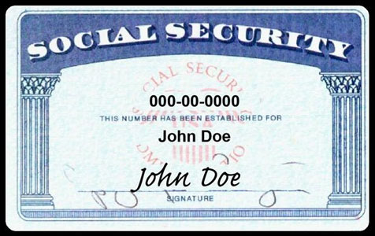
Please make sure all (3) documents match
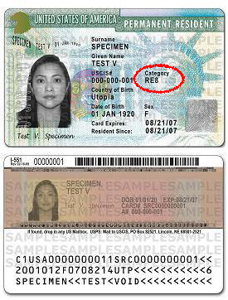

If, in the process of name change, please provide paperwork, such as reciepts or whatever is given.

Authorization to Release Information & Waiver

To Whom It May Concern:
I am an applicant for the position of_________________________________________________________with the Orange County Sheriff-Coroner Department. As a matter of department policy, my prospective employer is required to conduct a thorough investigation into my personal, medical, and psychological fitness to serve in this capacity.
I hereby direct you, your organization, its Custodian of Records, and/or persons in your employment to release all information which you may have concerning me, including information may be confidential, privileged and/or derogatory in nature, including but not limited to: employment information, official employment documents, employment performance data, character reference information, education records and transcripts (pursuant to Public Law 93-380), medical, surgical, psychological and dental records. If I am offered employment with this agency (pursuant to the Medical Information Act, Civil Code Section 56 et. Seq. and C.F.R. 1630), credit and financial information (pursuant to Banking Privacy and Fair Credit Reporting Acts), local criminal history information (pursuant to Penal Code section 13300[b][10]), and/or any other information that you possess. By signing this form, I acknowledge that I have received notice and have provided consent for the Orange County Sheriff’s Department to use this information to conduct such a background investigation, which may include the searching of public databases, private databases, criminal databases, and law enforcement databases including, but not limited to, COPLINK, LINK, C-ALL, DDEX, and NDEX.
I exonerate, release and discharge you, your organization, its officers, agents, and assigns, from any liability or damages, whether in law or in equity, for furnishing the truthful information requested by the bearer of this authorization form.
A photocopy of this release form will be valid as an original thereof, even though the said photocopy does not contain on original writing of my signature.
The signing of this document authorizes its execution and acknowledgement that I have received a copy of it.
THIS RELEASE WILL EXPIRE ONE YEAR AFTER THE DATE OF SIGNATURE.

FULL NAME: |  | ADDRESS:
 | (Signature to be witnessed)
PRINT NAME: |  | CITY/STATE:
DATE: |  | TELEPHONE:
A notary public or other officer completing this certificate verifies only the identity of the individual who signed the document to which this certificate is attached, and not the truthfulness, accuracy, or validity of that document.
State of California
County of
On | before me,
 | (insert name and title of the officer)
personally appeared
who proved to me on the basis of satisfactory evidence to be the person(s) whose name(s) is/are subscribed to the within instrument and acknowledged to me that he/she/they executed the same in his/her/their authorized capacity(ies), and that by his/her/their signature(s) on the instrument the person(s), or the entity upon behalf of which the person(s) acted, executed the instrument.

I certify under PENALTY OF PERJURY under the laws of the State of California that the foregoing paragraph is true and correct. WITNESS my hand and official seal.
Signature:_____________________________________ | (Seal)

PERSONAL HISTORY STATEMENT
INSTRUCTIONS: | Please type. Each question must be answered. If the question does not apply, enter “DNA” in the space provided for the answer.

PART I PERSONAL DESCRIPTION
1. Legal Name |  | Last |  | First |  | Middle
2. Aliases-Nicknames (List all names you have ever been known by and the circumstances)

3. Date of Birth |  | 4. Place of Birth (City, County, State) |  |  | 5. Social Security Number
6. If a Naturalized Citizen, list the City, County and State where Naturalized.

7. Sex | Age | Height | Weight | Build (Light, Medium, Heavy) | Complexion | Hair | Eyes
8. Scars, tattoos, or other distinguishing marks.

PART II RESIDENCE INFORMATION
9. Residence address (Number, Street, City, State, Zip Code)

List the telephone number(s) where you can be contacted. |  | E-mail Addresses:
Home # | Cell # | Primary:
 |  | Secondary:

PART III MARITAL INFORMATION
10. Marital Status (Check one or more) | ☐Never Been Married  ☐Divorced | ☐Married  ☐Widowed | ☐Separated  ☐Remarried
11. Name of Present Spouse (First, Middle, Last Name)

12. If divorced or annulled, list prior marriages in order of occurrence. (If additional space is needed, use the back of this page)
Name and addresses of former Spouses:

PART IV EMPLOYMENT INFORMATION
13. | Begin with the most recent job and list your work history for the past 5 years in chronological order. Include in sequence, all part-time jobs, periods of employment, periods of unemployment and military service. List each duty station with complete military address including unit  designation. Do not duplicate the names of persons whom you listed as references. (For the purposes of this personal history statement, volunteer work should be included as employment.)
From |  | Employer’s Name | Employer’s Address (Number, Street, City, State, Zip) |  | Area Code/Telephone
To |  | Job Title |  | Duties
Supervisor Name - Area Code/Telephone |  |  |  | Supervisor Email Address
Co-Worker Name - Area Code/Telephone |  |  |  | Co-Worker Email Address
From |  | Employer’s Name | Employer’s Address (Number, Street, City, State, Zip) |  | Area Code/Telephone
To |  | Job Title |  | Duties
Supervisor Name - Area Code/Telephone |  |  |  | Supervisor Email Address
Co-Worker Name - Area Code/Telephone |  |  |  | Co-Worker Email Address
From |  | Employer’s Name | Employer’s Address (Number, Street, City, State, Zip) |  | Area Code/Telephone
To |  | Job Title |  | Duties
Supervisor Name - Area Code/Telephone |  |  |  | Supervisor Email Address
Co-Worker Name - Area Code/Telephone |  |  |  | Co-Worker Email Address
From |  | Employer’s Name | Employer’s Address (Number, Street, City, State, Zip) |  | Area Code/Telephone
To |  | Job Title |  | Duties
Supervisor Name - Area Code/Telephone |  |  |  | Supervisor Email Address
Co-Worker Name - Area Code/Telephone |  |  |  | Co-Worker Email Address
From |  | Employer’s Name | Employer’s Address (Number, Street, City, State, Zip) |  | Area Code/Telephone
To |  | Job Title |  | Duties
Supervisor Name - Area Code/Telephone |  |  |  | Supervisor Email Address
Co-Worker Name - Area Code/Telephone |  |  |  | Co-Worker Email Address

PART IV EMPLOYMENT INFORMATION CONTINUED
From | Employer’s Name | Employer’s Address (Number, Street, City, State, Zip) |  | Area Code/Telephone
To | Job Title |  | Duties
Supervisor Name - Area Code/Telephone |  |  | Supervisor Email Address
Co-Worker Name - Area Code/Telephone |  |  | Co-Worker Email Address
From | Employer’s Name | Employer’s Address (Number, Street, City, State, Zip) |  | Area Code/Telephone
To | Job Title |  | Duties
Supervisor Name - Area Code/Telephone |  |  | Supervisor Email Address
Co-Worker Name - Area Code/Telephone |  |  | Co-Worker Email Address
From | Employer’s Name | Employer’s Address (Number, Street, City, State, Zip) |  | Area Code/Telephone
To | Job Title |  | Duties
Supervisor Name - Area Code/Telephone |  |  | Supervisor Email Address
Co-Worker Name - Area Code/Telephone |  |  | Co-Worker Email Address
From | Employer’s Name | Employer’s Address (Number, Street, City, State, Zip) |  | Area Code/Telephone
To | Job Title |  | Duties
Supervisor Name - Area Code/Telephone |  |  | Supervisor Email Address
Co-Worker Name - Area Code/Telephone |  |  | Co-Worker Email Address
From | Employer’s Name | Employer’s Address (Number, Street, City, State, Zip) |  | Area Code/Telephone
To | Job Title |  | Duties
Supervisor Name - Area Code/Telephone |  |  | Supervisor Email Address
Co-Worker Name - Area Code/Telephone |  |  | Co-Worker Email Address

PART V TRAFFIC INFORMATION
14. Driver’s License Number and State | Class of License | Expiration Date

PART VI ARREST INFORMATION
15. ☐Yes☐No | Have you ever been detained by a law enforcement officer? If the answer is “Yes”, explain below why you were detained.
16. ☐Yes☐No | Have you ever been arrested and released by a misdemeanor citation? If the answer is “Yes”, what was the offense listed on  the citation? Please explain.
17. ☐Yes☐No | Have you ever been arrested and booked into a jail facility? If the answer is “Yes”, what was the offense and where were you  booked? Please explain.

PART VII EDUCATION INFORMATION
18. Check highest grade completed: 8 9 10 11 12 AA Bachelors Masters
19. List all colleges and universities you have attended. Include post-graduate work.
Name of School | Complete Address (Number, Street,  City, State, Zip) | Attendance Dates |  | Graduate |  | Degree or Units Earned
 |  | From | To | Yes | No
20. List every school (High School, Trade School, or Business College) that you have attended. Start with the one you last attended.
Name of School | Complete Address (Number, Street,  City, State, Zip) | Attendance Dates |  | Graduate |  | Major
 |  | From | To | Yes | No

21. Is there anything else you wish to disclose that will assist us in conducting your background investigation more expeditiously? If “Yes”, please explain.
BACKGROUND INVESTIGATION CONSENT
I, the undersigned, authorize the Orange County Sheriff’s Department, and its agents, to independently research my background, character, credit and criminal record, past employment, and education. This includes contacting references and other persons, reviewing records maintained by any of these persons, both public and private organizations. This may include investigating whether you have been involved in any insurance, unemployment, or worker’s compensation related fraud.
Date | Signed
PART VII MISCELLANEOUS INFORMATION

